Chapter 2
Assignment

- Given the Figure 1
a. Draw the output waveform for the 3-input OR gate of Figure 1

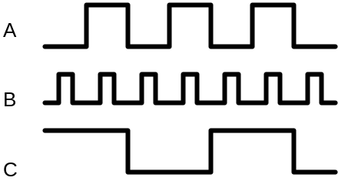

Figure 1

b. Suppose that A input in the figure is unintentionally shorted to ground (i.e., A=0). Draw the resulting output waveform.
c. Suppose that A input in the figure is unintentionally shorted to the +5V supply line (i.e., A=1). Draw the resulting output waveform.

2. Chang the OR gate in Figure 1 to an AND gate.
a. Draw the output waveform.
b. Draw the output waveform if the A input is permanently shorted to ground.
c. Draw the output waveform if A is permanently shorted to +5V.

3. Given the Figure 2
a. Apply the input waveforms of Figure 2 to a NOR gate, and draw the output waveform.
b. Repeat with C held permanently LOW.
c. Repeat with C held HIGH.

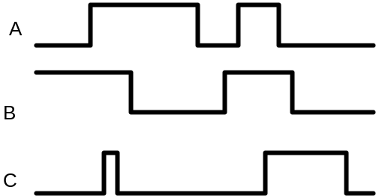 Figure 2

4. Repeat Problem 3 for a NAND gate.
5. Write the expression for the output of Figure 3, and use it to determine the complete truth table. Then apply the waveforms of Figure 2 to the circuit inputs, and draw the resulting output waveform.

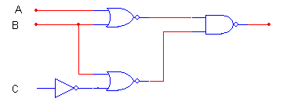
Figure 3

- Given the function
F(D,C,B,A) = D’C’B+ AD + C
- Build the truth table for F
- Draw the circuit diagram
- Draw the pulse diagram
- Implement the function using 2-input NAND gates.
- Implement the function using 2-input NOR gates.

- Prove the following equalities
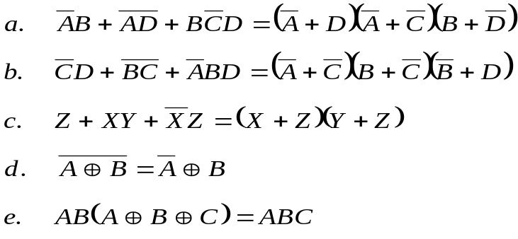

- Given the Truth Table as follows
C | B | A | F1 | F2
0  0  0  0  1  1  1  1 | 0  0  1  1  0  0  1  1 | 0  1  0  1  0  1  0  1 | 0  0  1  0  0  1  0  1 | 1  0  0  1  1  1  1  0

- Write the expression for F1 in term of POS
- Write the expression for F2 in term of SOP
- Simplify function F1 and F2 using K-map

- Given the Truth Table as follows
C | B | A | F1 | F2
0  0  0  0  1  1  1  1 | 0  0  1  1  0  0  1  1 | 0  1  0  1  0  1  0  1 | 1  0  X  0  0  1  X  0 | 1  X  0  1  1  X  X  0

- Write the expressions for F1 and F2
- Write F1 and F2 on term of Σ and ∏
- Simplify functions F1 and F2 using K-map
- Given the following functions:
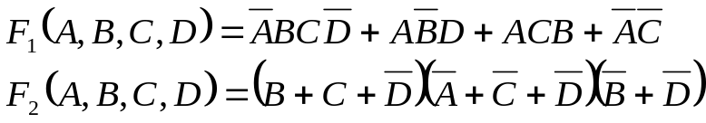
Write the Truth table for F₁ and F₂ and simplify functions F1 and F2 in K-map
- Given the following functions:
F₁(A,B,C,D) = Σ(0,1,2,4,6,8,12) + d(3,13,15)
F₂(A,B,C,D) = ∏ (1,3,4,5,11,12,14,15).d(0,6,7,8)
Write the Truth table for F₁ and F₂ and simplify functions F1 and F2 in K-map

- Given the following pulse diagram

A

B

C

D

F1

F2

F3

- Write the expressions for F1, F2 and F3.
- Write F1, F2 and F3 in term of Σ and ∏
- Simplify functions F1, F2 and F3 in K-map

- Given the Truth Table as bellows
A | B | C | D | F1 | F2
0  0  0  0  0  0  0  0  1 | 0  0  0  0  1  1  1  1  x | 0  0  1  1  0  0  1  1  x | 0  1  0  1  0  1  0  1  x | 1  0  0  0  1  0  0  0  1 | 1  1  0  1  1  1  0  1  0

a. Write the expressions for F1, F2 and F3.
b. Write F1, F2 and F3 in term of Σ and ∏
c. Simplify functions F1, F2 and F3 using K-map

- Find the standard form 1 and 2 of the following functions:
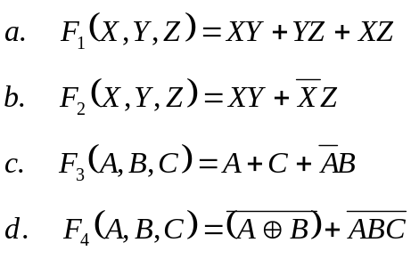

- Simplify the following functions using K-map
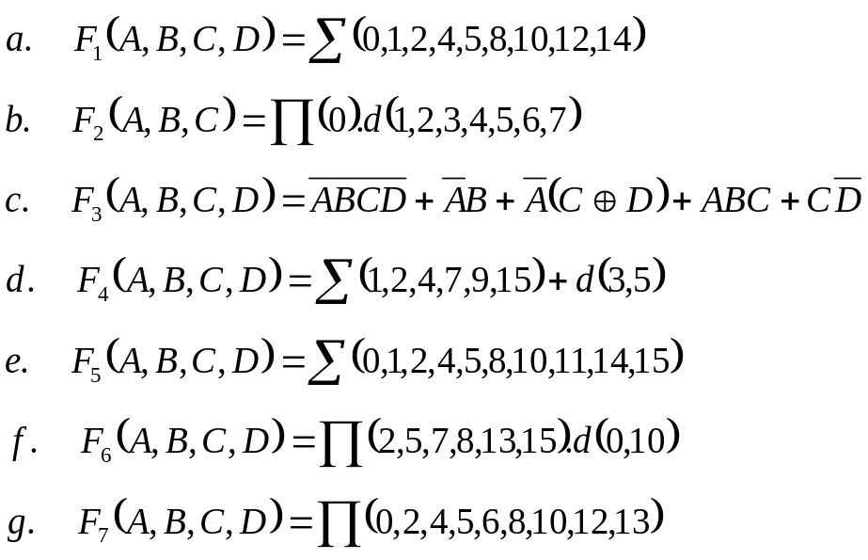
- Simplify the following functions using K-map
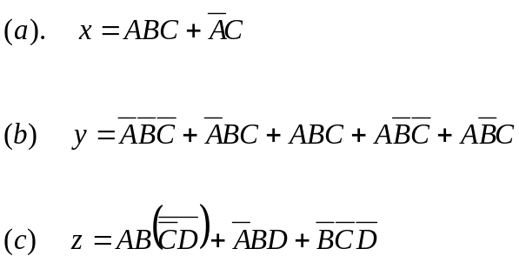

A
B
C
D
F

- Write the standard form 2 of function F
- Represent F into K-map
- Simplify the function F and draw the circuit diagram using only NAND gate.
- Implement the function 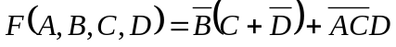using NAND gate.
- Implement the function 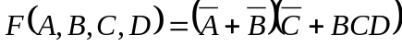 using NOR gate.
- Given the following functions:
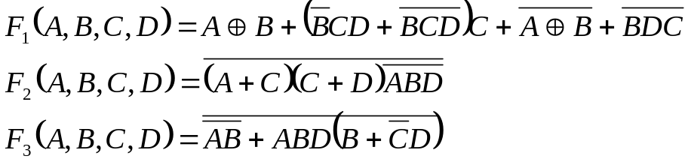
- Represent the functions into K-map
- Write the functions in term of POS
- Simplify and draw the circuit diagram using only NAND gate.

- Given the following functions:
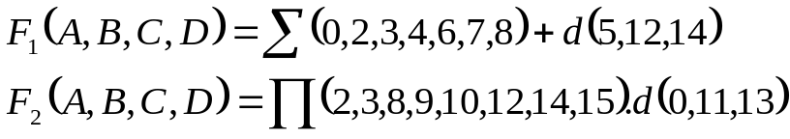
- Simplify the functions F1 and implement F1 using AND-OR gates.
- Simplify the functions F2 and implement F2 using AND-OR gates.
- Implement F1 using only NAND gates.
- Implement F2 using only NOR gates.

